Navigating your Library Search
Start at the Lamar University Homepage. The link to the library is on the top toolbar.



You will be taken to the Mary and John Gray Library homepage and will need to use your username and password to sign in. Before beginning to type in the search, move the arrow and select your databases.
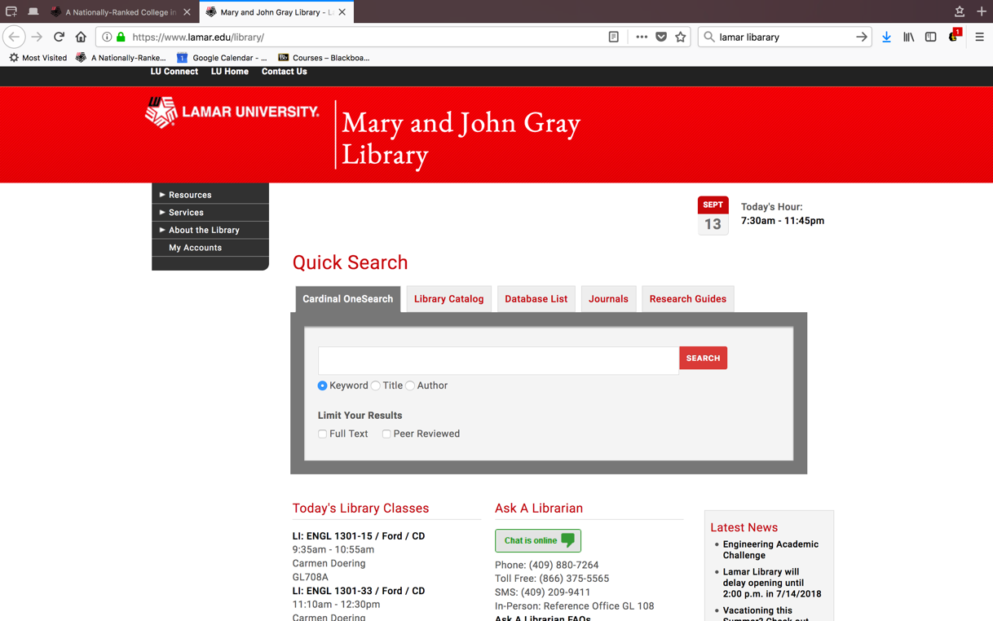

Begin by highlighting the “P”
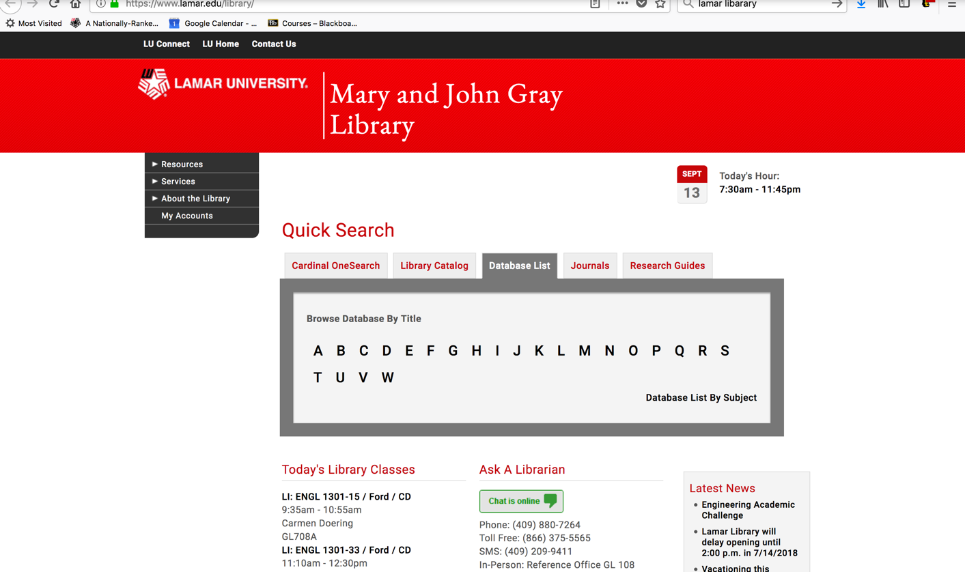
Select one or more appropriate databases, such as PsycInfo.


Type in your keywords and select your search strategies to focus the search and select the appropriate field for the term. For example, selecting “Title” will produce fewer hits than selecting “All Text.” Also use the Boolean operators to broaden or narrow results.
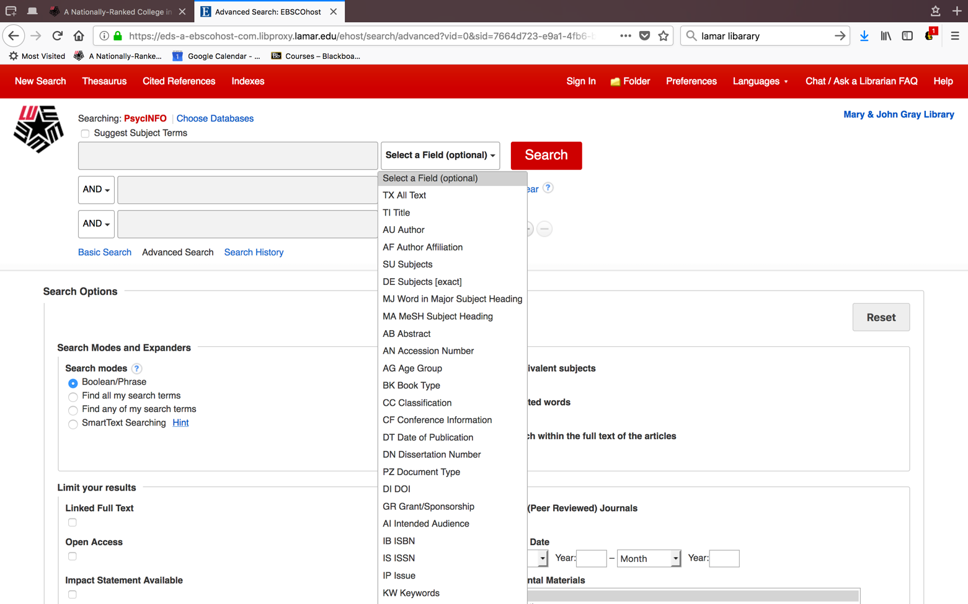

Also, you might want to limit your results to only scholarly peer reviewed journals and full text. Select the “Published Date” setting to be within 10 years.

